
Radio Station

Challenge Cards

Radio Station

Challenge Cards

Challenge Cards

Radio Station

Challenge Cards

Radio Station


Can you use sound effects to record a scary voice for Halloween?

Can you use sound effects to make a voice recording sound like a chipmunk?

Can you change the tone and pitch of your voice to make your expression more interesting, in the style of a good radio presenter?

Can you use sound effects to make a voice recording sound like it has an echo?

Write an advert for a school radio station, persuading people to tune in and listen!

Write a description for a podcast which could be recorded for your school radio station.

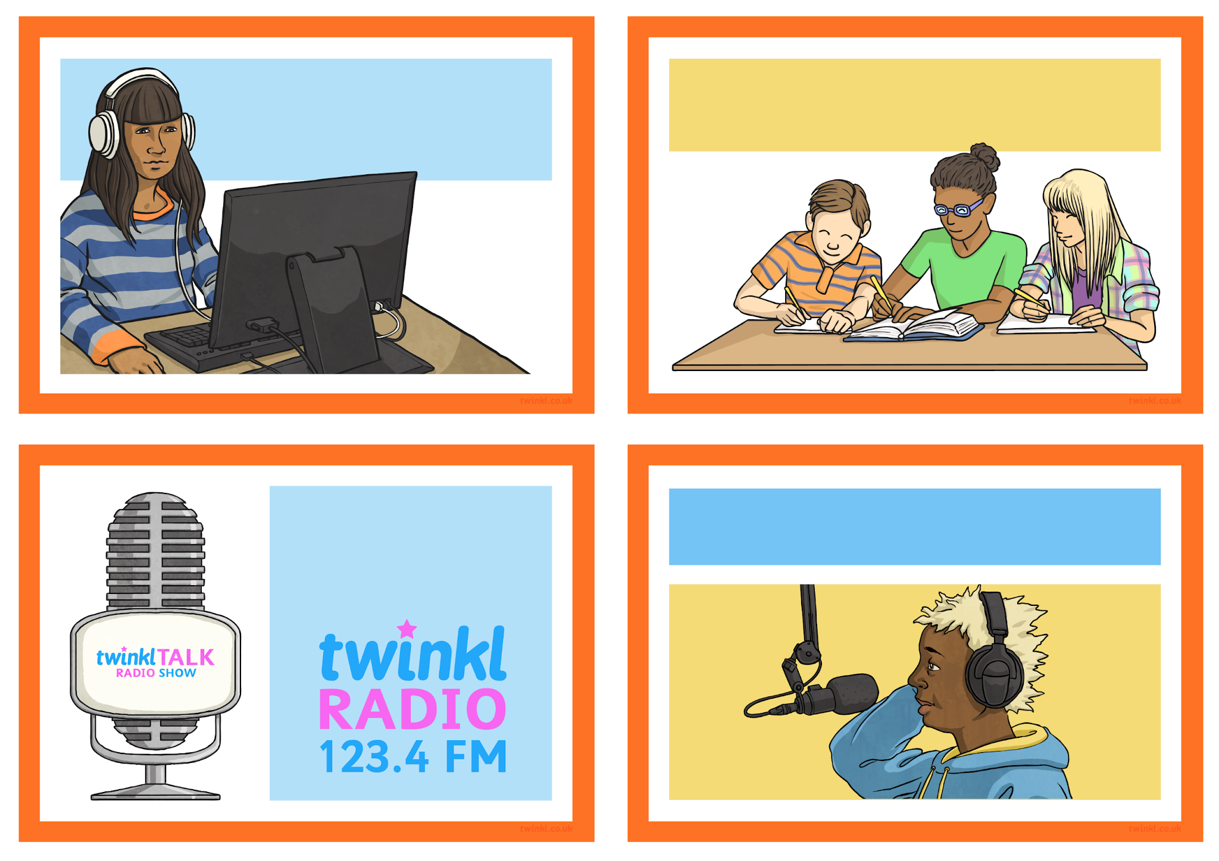

Research and write about a famous radio presenter from a local or national radio station.

Design or draw a new radio station logo. Think of a name and slogan.

Write a letter to a radio station or radio DJ telling them about your work. You could ask some questions too!

Make a glossary/mini-dictionary of technical words related to a radio station or sound recording. Can you write definitions for them?



Write a script and/or record a news report about something in your local area. It could be serious, funny or just interesting.

Practise your interviewing technique with a partner. One person can be the interviewer while the other plays the part of a famous sports person musician or TV star!

